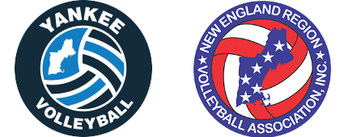
Yankee Board Meeting
10/23/2017
Time: 7 PM
Lincoln Sudbury High School, Lincoln, MA

- Approval of Prior Minutes

- Reports
  - Treasurer’s Report (Mark)
  - Registrar’s Report (Judy)
  - NERVA Report (Dave)
  - Rating’s Report
    - Men’s (Jeff)
    - Women’s (Jordan)
  - Social Media Report
  - Web Editor Report (Sam)
  - GRC Report (Jeff)
  - Tournament Director’s Report (Mark)

- Online Business (discussed via email)
  - Rules Suggestions – From John’s Email Chain

- Old Business
  - Stipend Review
  - New Facilities

- New Business
  - BCC Planning
  - Rating Clarifications
  - Sanctions Update
  - Tournament Director Responsibilities
  - Facility Quality & Recommendations

- Executive Session

Key Future Dates
- Future Meetings: January 3rd, April 26th
- Boston Volleyball Festival: March 3 and 4
- Nationals: May 25th to May 30th (Dallas, TX)
- Yankee Picnic: June 9th

