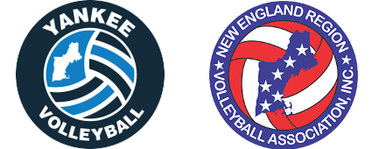
Yankee Board Meeting
1/03/2018
Time: 7 PM
Conrad’s, Sudbury, MA

- Approval of Prior Minutes

- Reports
  - Treasurer’s Report (Mark)
  - Registrar’s Report (Judy)
  - NERVA Report (Dave)
  - Rating’s Report
    - Men’s (Jeff)
    - Women’s (Jordan)
  - Social Media Report (Jordan)
  - Web Editor Report (Sam)
  - GRC Report (Jeff)
  - Tournament Director’s Report (Mark)

- Online Business (discussed via email)
  - None

- Old Business
  - -2 Ratings in Tournaments
  - Rating Clarifications – Ratings Sheet Makeover

- New Business
  - BCC Update
  - Sanctions Update
  - Facilities Review
  - National Room Block
  - National Roster Approval Timing
  - Online Payments for Tournaments

- Executive Session

Key Future Dates
- Future Meetings: April 26th
- Boston Volleyball Festival: March 3 and 4
- Nationals: May 25th to May 30th (Dallas, TX)
- Yankee Picnic: June 9th

