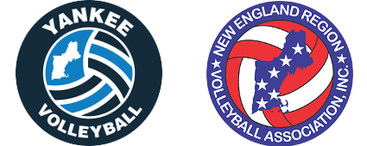
Yankee Board Meeting
4/25/2019
Time: 7 PM
Lincoln Sudbury High School, Sudbury, MA
- Approval of Prior Minutes
  - Prior minutes were approved on-line

- Reports
  - Treasurer’s Report (Mark)
  - Registrar’s Report (Judy)
  - NERVA Report (Judy)
  - Rating’s Report (Jeffry)
  - Social Media Report (Jeffry)
  - Web Editor Report (Jeffry)
  - GrassRoots Campaign Report (Jeffry)
  - Tournament Director’s Report (Mark)

- Online Business (discussed via email)

- Old Business
  - Ratings Sheet Makeover
  - BCC Results / Success
  - Board Elections Update
  - Yankee Picnic Planning
  - Transgender Policy
    - “Per Dave, we will allow any transgender athlete to play in any adult tournament as the gender they identify with. If there are any changes Dave will notify us. We will rate this player as the gender they identify with.”

- New Business
  - Steve Simmons
    - Men’s and Women’s Ratings for RCO
    - Women’s Ratings for Men’s Tournaments
    - Yankee and Beach/Grass Volleyball during the Summer months

- Executive Session
  - Executive session will be held

Key Future Dates
- Nationals: May 24th to May 29th (Columbus, OH)
  - A/AA: Fri/Sat/Sun
  - B/BB: Mon/Tue/Wed
- Yankee Picnic: Sunday, June 9th

